THE STUDIO & FORUM OF SCENIC ARTS
#3 FORUM SEMINAR Spring 2022: Revised dates
FAUX FINISHES: Stone and Brick -

Taught by JANE SNOW and DIANE FA RGO
2 SESSIONS, Saturday & Sunday, February 19th & 20th . 9am-3pm

Location: 300 Shore Road, Cornwall, NY 12520
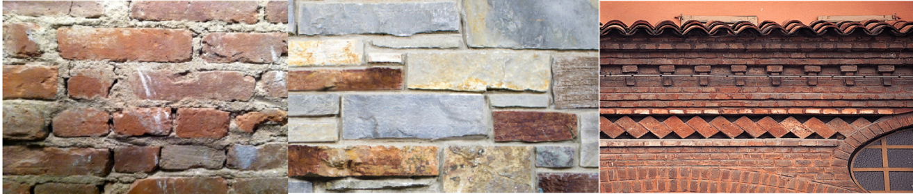
For more information contact Kyle at 845.522.8478 khiggins@studioandforum.org
NEW DATES! #3 STONE and BRICK HAS BEEN MOVED to
FEBRUARY 19th and 20th!

This seminar will explore various techniques on hard panels involving painted and/or textural treatments in stone and brick. Students will experiment with various textures and finishes com- mon in the film and theatre industries, and will learn proper architectural layouts to make their masonry look realistic. Students may go on to the next course which will incorporate dimen- sional carvings into their brick and/or stone panels. The Stone and Brick class, a 2-day course, is $400. Pricing includes all materials.
A Discount of $50 will apply if you take both the Stone & Brick and the Carving Masonry
semi-nars, or $925 for two.

Jane Snow is the Managing Director of the Studio and Forum and an 829 Scenic Artist.
Diane Fargo is the Senior Lecturer in Scene Painting at Boston University’s College of Fine Arts.
---------------------------------------------------------------------------------------------------------------------------
Please detach registration slip and, if you are a New Student, include signed Proof of Vaccination and Photo Release Forms with full payment via check, PayPal, or Zelle to:
Studio & Forum of Scenic Arts c/o Kyle Higgins, 11 Oak Place, Croton, NY 10520 or khiggins@studioandforum.org
Name: Address: City/State/Zip:
Phone: Email:
Emergency Contact: Phone:
#3 Brick and Stone Seminar - Feb. 19& 20, 9am-3pm

